Design Research



Date : 17.03.2022

Version : 0.4

Authors : Aleksandar Hadzhiev and Felix Morenc

Version history

|  |  |  |  |
| --- | --- | --- | --- |
| Version | Date | Author(s) | Changes |
| *0.1* | *10.03.2022* | *Aleksandar Hadzhiev* | *Initial Version* |
| *0.2* | *15.03.2022* | *Aleksandar Hadzhiev* | *Added References and Define phase* |
| *0.3* | *16.03* | *Aleksandar Hadzhiev* | *Added Testing and Prototyping* |
| *0.4* | *17.03* | *Felix Morenc* | *Edited, expanded, and revised document, edited styling* |

Table of contents

I. Empathize 2

II. Define 6

III. Ideation 7

IV. Prototype 8

V. Testing 11

VI. References 11

# Empathize

At the beginning we received the topic for our project and a persona, which would guide our work on this project. The topic was shopping, and the persona was [Ambitious](https://fhict.instructure.com/courses/12038/modules/items/746849) corporate warrior John.

Картина, която съдържа текст

Описанието е генерирано автоматично

Given that the topic was shopping, we immediately started thinking of the act of shopping itself and with John as our persona we had to narrow it down to people who are job oriented and in their 30s to 40s. Unfortunately, the information regarding the persona was insufficient so we researched more about our target groups.

What we found from this research was that men and women have significantly different preferences when it comes to shopping, which led us to choose only one of the two genders and given that our persona was a male, we decided to continue with the male gender.

Here are the main differences between the genders and what men prefer in shopping:

**Preferences**

|  |  |
| --- | --- |
| **Male Preferences** | **Female Preferences** |
| Focused on the goal | Shop based on future needs |
| Result > Process | Buy gifts for others too |
| Stop shopping after finding a suitable option | Make impulse purchases |
| Simple and straightforward experience | Tend to follow trends and fashion, and make the purchasing decision with them in mind |
| Logical thinking before buying | Enjoy the shopping process as a whole and tend to spend more time shopping online |
|  | More receptive to other people’s opinions |

**Shopping Profile**

|  |  |
| --- | --- |
| **Male Profile** | **Female Profile** |
| Computer and tech | Clothes and sports goods |
| Travel and holiday accommodation | Books, magazines, and electronic educational literature |
| Household items | Groceries |
| Tickets for events | Medicine |
| Media content – movies and music |  |
| More brand loyal, okay with spending more money |  |

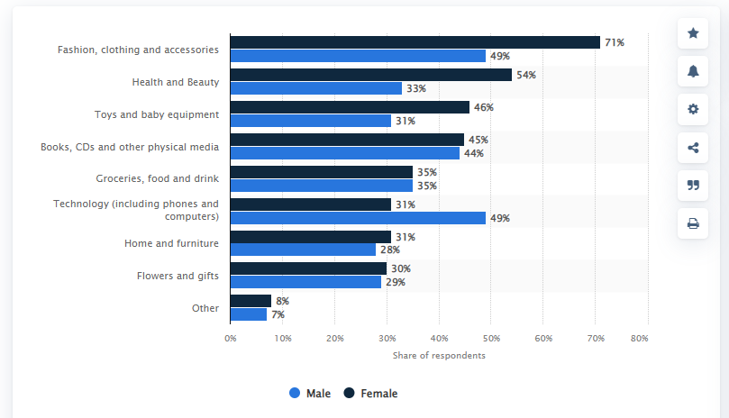

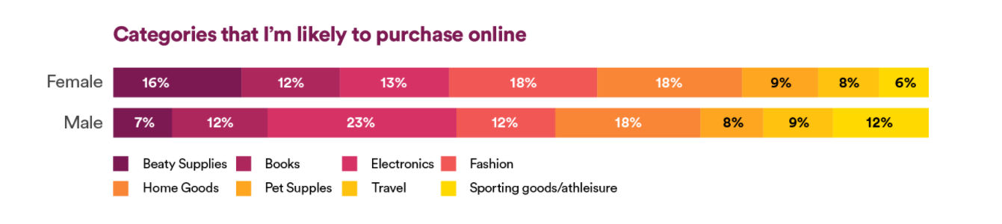

**Color preferences**

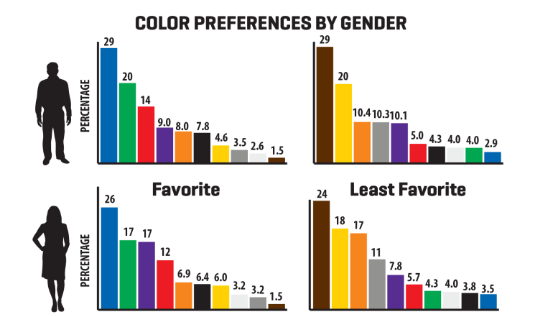

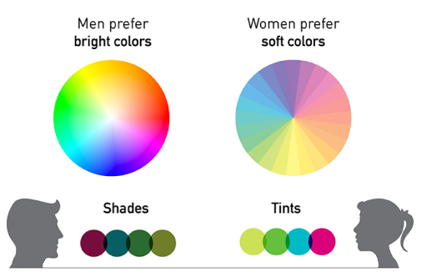

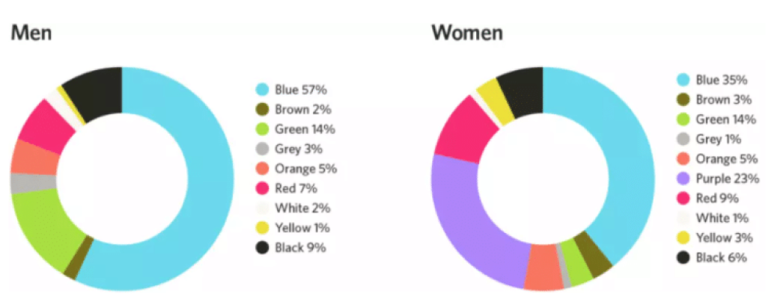

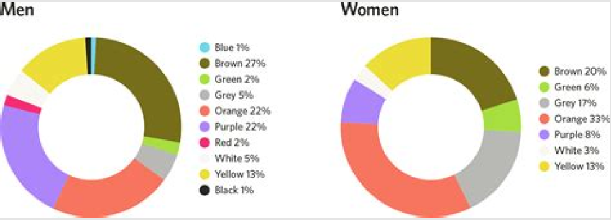

Based on the data, we saw that there are some significant differences for both genders and it would be hard to please them both at the same time, this resulted in us deciding to choose only one of them to continue our research on.

# Define

Now with a better understanding of our target group and their needs, we had to define the problem which this project will aim to solve. What we found is that there is not a core problem to be fixed, if we were to create an app, to be used by our target group and will need to keep in mind the possibility of expanding outside of it. Problems such as:

* Shortening the process
* Simplifying the process
* Keep it entertaining

These three problems formed the main problem for this project which is: ***“How to optimize the shopping process?.”* Before we tried to fix the main one, our goal was to solve the smaller ones, which are already big problems by themselves.**

# Ideation

Now that the problem this project must solve has been defined, we had started to think of ways to solve it. We looked for apps which are already in this space and discovered there are a lot of options, because online shopping is nothing new. These apps work on solving the problem ahead of us, but not for our target group and that is when we saw the tinder-style shopping app online.

At the beginning of the project, we thought more of an app which will serve as a tool to connect to existing websites and physical stores for clothes shopping, however we decided that would not really help us solve the problem at hand, as these sites already existed but were not necessarily aimed for our target group.

Another potential concept for an app that came up was an app which would be more like a navigation for shops, using google maps and displaying them on the screen. This idea wound up being given up early on, as google maps and other map tools already have similar functionality at hand, given that you can see what is where on the map.

After some discussion and feedback from our teachers we ended up following the tinder like shopping app idea. Given that we wanted to simplify the process and shorten it, this idea served as a great tool to do that. Of course, we had to build an MVP of the project, so a lot of the actual functionalities, will not be included at the end of the project. Functionalities such as:

* Creating a profile
* Machine learning for the app to build the user a profile and present him with options
* AR (Augmented Reality) to show the user using the phone camera how clothes look on him.

On the other hand, functionalities which will be implemented are:

* Choosing the type of clothing
* Swiping left or right/ using buttons, based on whether you liked the clothing presented to you
* Purchasing within the app
* SMS sender/receiver, to notify the user that his purchase has been completed.

For the swiping/ buttons functionality we asked our fellow students for feedback, based on our prototype, the feedback was good with space for improvement and a lot of ideas to improve the design and the functionality. What we understood is that, without a hint, the users will not know that they have the swiping functionality and that if there are buttons and swiping, a lot of users will prefer the usage of buttons.

Of course, we asked them what they think will help us fix the little issue which we have, and we were given three great ideas, which are yet to be implemented.

* Display a small picture/animation to hind the users they should use swiping.
* A flashing animation, which shows what to do, when opening the page for the first time.
* A hint will be given, if the user only uses the buttons, which will notify him that there is also the possibility of swiping and that it is preferable.

We liked all the ideas, but all of them have some cons to them, for example the picture will start to get in the way or slightly annoy users after they learn the mechanism of the app. For the flashy animation, while seeming like the ideal solution, the main con was that not all users like such animations since it delays them from working with the app itself. As for the hint, the biggest con is that, even with it, users might continue using the buttons and just get annoyed at the hint being shown to them.

Right now, the project is using both functionalities at the same time, until an effective solution is found for the issue at hand. There is a fourth idea born from the combination of the first and the second one, which is about using the small picture at the bottom and then after the first opening of the app to remove the picture, so it does not bother the users anymore.

# Prototype

Existing design ideas used as templates:

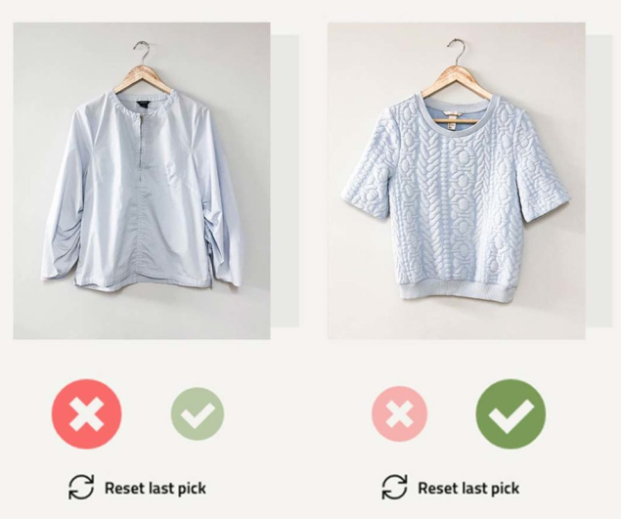

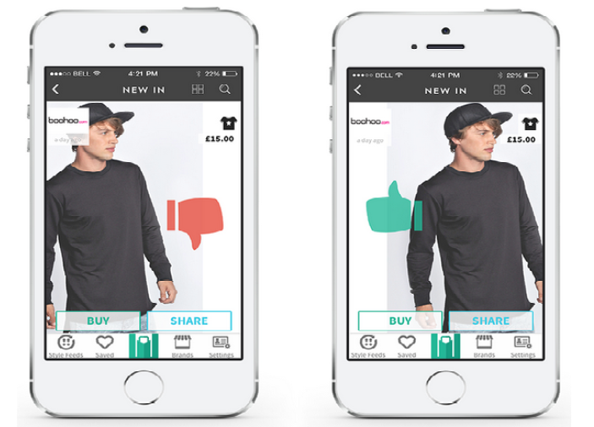

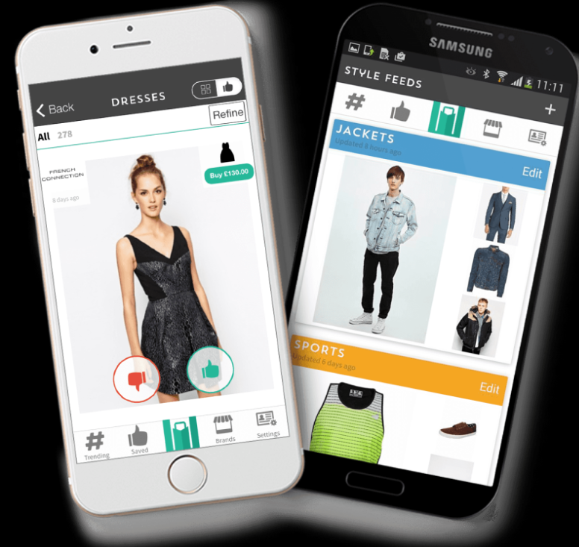

The design for the app:

* First Page

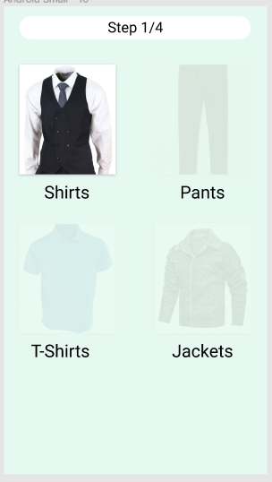

* Second Page

Картина, която съдържа текст, пуловер

Описанието е генерирано автоматично Картина, която съдържа текст, пуловер

Описанието е генерирано автоматично

* Third Page

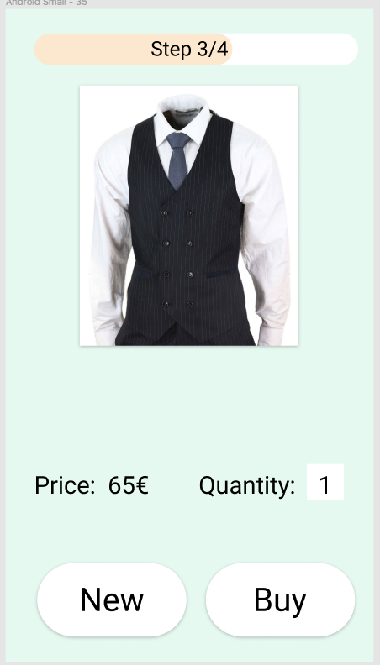

* Pop up Menu

Картина, която съдържа текст

Описанието е генерирано автоматично

# Testing

We could not test the application with users from the target group.

# References

Rancea, B., Bogdan Rancea Bogdan is a founding member of Inspired Mag, Bogdan is a founding member of Inspired Mag, & *, N. (2021, September 15). *Male shopping habits versus female shopping habits*. Ecommerce Platforms. Retrieved March 15, 2022, from <https://ecommerce-platforms.com/articles/male-shopping-habits-versus-female-shopping-habits>

Robinson, J. (2021, November 5). *Difference between men and women shopping: Sageseller*. Sageseller.com. Retrieved March 15, 2022, from <https://sageseller.com/blog/difference-between-men-and-women-shopping-behaviors/>

Burke, M. (2021, August 4). *Men Vs Women Shopping Statistics, behaviors & other trends*. Jungle Scout. Retrieved March 15, 2022, from <https://www.junglescout.com/blog/men-vs-women-shopping/>

Chevalier, S. (2021, October 19). *U.S. online shopping categories by gender 2017*. Statista. Retrieved March 15, 2022, from <https://www.statista.com/statistics/311406/us-online-shopping-categories-gender/>

Fletcher, D. (n.d.). *Shopping habits by gender: What's changed in 2020*. Clearsale Blog. Retrieved March 15, 2022, from <https://blog.clear.sale/shopping-habits-by-gender-whats-changed-in-2020>

*Men vs. women: How they shop*. Crobox Blog. (n.d.). Retrieved March 15, 2022, from <https://blog.crobox.com/article/men-women-shopping-differences>

The Times of India. (2021, October 26). *Differences in shopping habits between men and women - times of India*. The Times of India. Retrieved March 15, 2022, from <https://timesofindia.indiatimes.com/life-style/fashion/buzz/differences-in-shopping-habits-between-men-and-women/articleshow/87263287.cms>